**Chapter 5 Relay Selection**

Relay selection is one of the main buildings blocks of cooperative relaying and commonly channel conditions of relay links are main selection criteria. The impact of choosing a given relay node on communication of surrounding nodes and overall network has to be taken into account. The relay selection is mainly done once at network start up periodically at transmitting section. Many papers have been published based on different relay selection approaches. [Survey on Cooperative Relay Selection Approaches Nimmi Krishna M.R, Shiras S. N Department of Electronics and Communication, MBCET, Trivandrum, India] Also, Unreasonable selection of the relays to retransmit important information could seriously degrade the ITS applications performance in terms of latency, overhead, and reception rate. The terrible performance of the decision might have devastating consequences on the performance of the ITS applications and consequently on the safety of drivers and pedestrians. [Alotaibi M. Relay Selection for Heterogeneous Transmission Powers in Connected Vehicles[D]. Université d'Ottawa/ University of Ottawa, 2017.]

However, many relay selection schemes demand the continuous monitoring of all available channel links, Regarding the relay selection mechanism, threshold-based relay selection has been proposed as an efficient technique for improving performance. [ S. S. Ikki and M. H. Ahmed, “Performance of multiple-relay cooperative (A-1) diversity systems with best relay selection over Rayleigh fading channels,” *EURASIP J. on Advances in Signal Processing*, p. 145, 2008.]

**5.1 Relay selection methods**

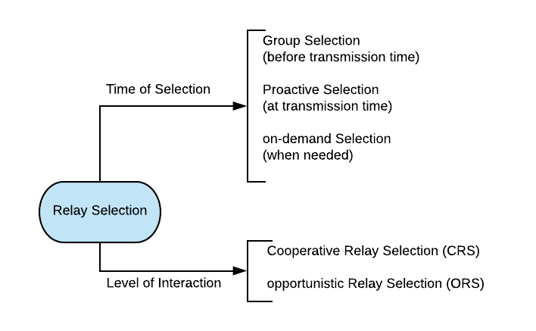

**Figure.1. relay selection taxonomy**

According to the figure.1, based on the time of selection, it is divided into the following three categories.

**Group Selection:** it selects relay before transmission in order to achieve some pre-defined performance.

**Proactive Selection:** it selects relay during transmission according to the source and the destination.

**On-demand Selection:** it selects relay when the relay is needed.

Also, based on the level of interaction, it is divided into the following two categories.

**Opportunistic Relay Selection:** it selects relay based on the information which is about the network each potential relay.

**Cooperative Relay Selection:** it selects relay based on the useful information about the acceptance to relay and local situation from relay broadcasting.

For a better understanding of the existing relay selection methods, the following figure.2 will be helpful to identify the similarities among these relay selection methods.

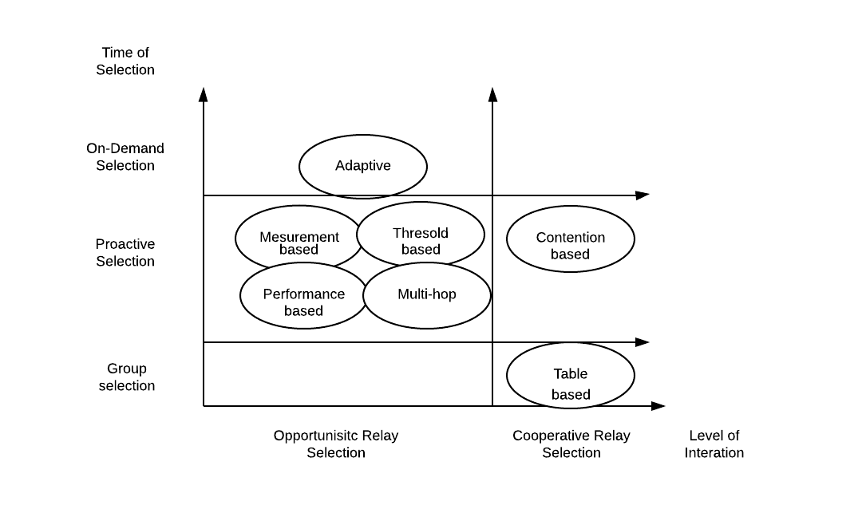

**Figure.2 Classification of relay selection methods**

From figure.2, measurement-based, threshold-based and performance-based relay selection approaches are proactive and opportunistic relay selections, which means a relay that is always selected based on local information during transmission. The adaptive relay selection is an on-demand and opportunistic selection category, which means a relay that is selected if needed.

Also, we can find that two categories are divided under cooperative relay selection. One based on the selection of group of relays is called table-based relay selection. Another one based on the selection of a set of a variable number of relays is called contention-based relay selection.

**5.1.1 Measurement-based Relay Selection**

The measurement-based relay selection is based on the local measurements of instantons channel conditions. Each potential relay estimates channel conditions. However, as we mentioned before, it is a hard work to collect the real time channel state information(CSI) for at the transmitter side under highway scenario. So this relay selection approach is not our choice for relaying messages for the next transmission.

**5.1.2 Performance-based Relay Selection**

The performance-based relay selection is based on the performance on delay and energy efficiency. All potential relays estimate their channel condition as well as the measurement-based relay selection. However, the channel estimation overhead will be limited with the measurement-based relay selection. This method is not suitable for our V2X communication system.

**5.1.3 Threshold-based relay selection**

The threshold-based relay selection relies on SINR and BLER thresholds to decide from a set of N available ones which node is satisfied for cooperation between the source and the destination. Coding and modulation scheme(MCS) is adapted to reach a target BLER value below 1%.

**5.2 Threshold-based relay selection algorithm**

The objective for designing the transmission system is to deliver the safety-related road information in a high speed with quite low latency. On the other hand, it is efficient to utilize the limited frequency and time resources. The threshold-based relay selection algorithm can meet these requirements in V2X communication systems.

**5.2.1 The advantages of threshold-based relay selection algorithm**

The threshold-based relay selection tries to increase network lifetime and transmission throughput. Also, it doesn’t need to collect the instant CSI information which is really a tough work. In addition, this algorithm can be combined with other algorithms in order to transmit safety-related information to drivers.

**5.3 context-aware selection of relays**

From the efficiency perspective, relay selection procedure should be executed and adapted. Thus some context information such as geometrical location and nearby traffic participants and environment information should be applied to optimize system performance. Thus, there are two technical components of context information that should be considered to selecting relays.

* Selection of relay UE(s)
* Collection of the useful context information

Before a packet is retransmitted over the first hop direct V2X communication, the transmitter needs to locally select proper receivers act as the relays. The main aim of the relay selection is to extend the transmission range that can support the most receivers which have the difficulty to successfully receive packets from the first hop direct V2X communication.

Moreover, the selection of relays should have limitation number, which cannot be arbitrarily large. Because we need to control the mutual interference and reduce the consumption of radio resource. However, if the number of the relays is too small, certain receivers will not be in the transmission range of any relay and therefore they cannot successfully receive the packet. So the performance of the direct V2X communication will be decreased.

In this work, since we inspect on the two-hop direct V2X communication on a highway scenario and potential receivers for traffic-related packets are either in the front side or in the back side of the transmitter, two relays will be selected to perform the second hop transmission for packets.

**5.3.1 context information**

Context information should be collected and presented at each V2X transmitter in order to operate relay selection procedure. For example, the real-time location and mobility pattern of data packet generator are embedded in each V2X data packet. Therefore, a V2X UE can receive and cache the information of the nearby traffic participants to predict their geometrical location in future.

**5.4 Relay Selection Algorithm**

**Algorithm 1: relay selection**

1: Deciding the appropriate MCS (modulation and coding scheme) and the threshold BLER.

2: BLER is derived from the SINR value of each transmitter.

3: Mapping the distance between each receiver and the transmitter to the BLER of each receiver.

4: Depending on the mapping table of distance and BLER calculated before, the distances of receivers which BLER values satisfied the threshold value are selected.

5: The distance of the receiver satisfied the maximal distance is the relay.

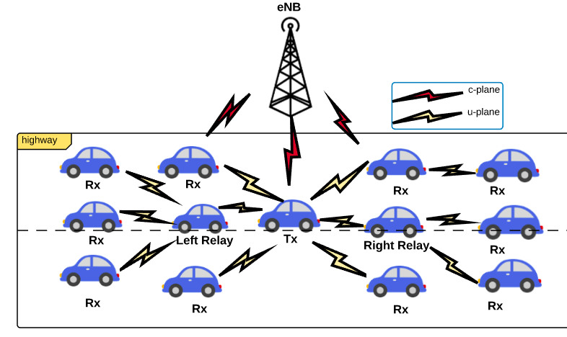

**Figure.3 V2X transmission through relay**

**Algorithm 2: Two side relays selection**

1: First, the receivers in the transmission range of the transmitter are divided into front and back two groups according to the position.

2: Deciding the appropriate MCS (modulation and coding scheme) and the threshold BLER.

3: Also, each receiver in two groups has its BLER.

4: Mapping the distance between each receiver of two groups and the transmitter to the BLER of each receiver.

5: Depending on the mapping table of distance and BLER calculated before, the distances of receivers which BLER values satisfied the threshold BLER value are selected for these two groups separately.

6: There are two groups of satisfied the threshold BLER value selected. The distance of the receiver satisfied the maximal distance is the relay. So the two relays are selected according to the two maximum distances in the two groups correspondently.

**5.4.1 Interference in the Second Hop direct V2X Communication**

It is worth noticing here because of the two side relays. They are both responsible for the second hop transmission of each packet and transmit the same packets for the second hop transmission by multiplexing the same radio resource or using the two same size radio resources respectively, which will also affect the second interference calculation.

* **Two same size radio resources**: Because the network can also allocate the same resource to different zones for the second hop direct V2X communication. So the receiver in the proximity of the relay will be affected by the transmitter using the same resource. Also, due to two same size radio resources. The front and the back relays transmitters will not affect the receivers in their transmission range respectively.
* **multiplexing the same radio resource**: As mentioned in two same size radio resources, the interference of the transmitter will not only have related with others using same resource. But also the front and the back relays transmitters will affect the receivers in their transmission range respectively. Because the two relays multiplexing the radio resource.

Therefore, a much higher interference power density for the second hop can be experienced at a receiver than the first hop.

**5.4.2 Mapping Table**

As mentioned in the relay selection algorithm, a mapping table from the packet transmission distance to the packet reception ratio is required, in order to select which receiver has a high probability to receive a packet from the first hop successfully and can act as relay. The transmission of cooperative awareness messages(CAMs) can contribute to obtain the information. Since CAM messages are periodically transmitted, a V2X receiver can record the successful reception or not of the CAM messages from the Transmitter to itself. As the location information of the transmitter has already embedded in the CAM message, the V2X receiver can calculate the distance between the transmitter and itself. Based these collected and calculated information, the mapping table from the distance and the estimated packet reception ratios can be created.

As mentioned before, the modulation is worth noticing which has been applied in LTE and it can provide different robustness. Therefore, the mapping table is created with different MCSs. For instance, if there are 15 optional MCSs and the estimated packet reception ratios should be collected with a communication range of 1000 meters and with a resolution of 5 meters, so the mapping table should have a dimensions of $15×200$.

As the following graph shows,



**Figure.4 mapping table graph with 15MCSs**

**5.5 Improving the performance by removing overlapped vehicles**

As figure.5 shows, we select right and left relays in the two sides of highway. In general, a receiver which is very close to the transmitter will not be selected. Because the receiver could almost have the same coverage like the transmitter. The dissemination range of the relay is

$Relay_range=Tx_range-Tx_opt$ (1)

where $Tx_range$ is the dissemination range of the transmitter; $Tx_opt$ is the maximum distance satisfied the threshold BLER. As the figure illustrates, the red line is the $Tx_range$, and the dark line is the $Tx_range$. The last green line is the $Tx_range.$

Because the transmission of the antenna equipped in the vehicles is isotropic. The coverage of the relay will have some vehicles overlapped with the coverage of the maximum distance of the transmitter, which means certain vehicle successfully receiving the messages would receive the same messages again. In this way, more time and frequency resources are wasted, which leads a low performance of the V2X system.

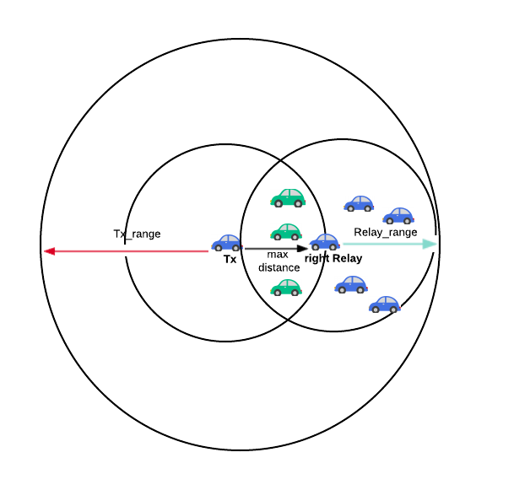

**Figure.5 overlapped vehicles**

As figure illustrates, we take the right side relay as an example. The green one are the overlapped vehicles in both ranges of the maximum distance and the relay transmission range.

There are two ways that can address this kind issue.

* **Removing overlapped vehicles**: it solves the issue by finding all the overlapped vehicles in the transmission range of the relays. And then remove them from the large group of vehicles.
* **Finding single side vehicles:** it solves the issue by just transmit the received messages to the vehicle which has the same side with the relay, which is based on the location information of each vehicles. Such as the right relay, we just need to transmit the selecting vehicles in the right side of the right relay.

Through reducing unnecessary transmission, the performance of the V2X system is increased.

The two relays receive the messages transmitted by the transmitter. And then the same messages are retransmitted to other vehicles in the dissemination range of the relays which do not receive the message successfully.

Through two relays transmitting, more vehicles in the transmission range of the transmitter are received the safety-related messages successfully in the V2X communication systems. Thereby, less traffic accidents will happen, and the traffic efficiency of the highway scenario will also increase.